Name: P.Vishwa nandan Reddy
Reg no:192473015

Set 3 and Set 4

SET 3: Employee Performance Evaluation
Task 1: Line Chart (Performance Trend)
Procedure
- Load the Employee Performance dataset.
- Open a worksheet.
- Drag Years of Service to Columns.
- Drag Performance Score to Rows.
- Choose Line Chart.
- Drag Department to Color.
- Add chart title Employee Performance Trend.
- Label both axes.
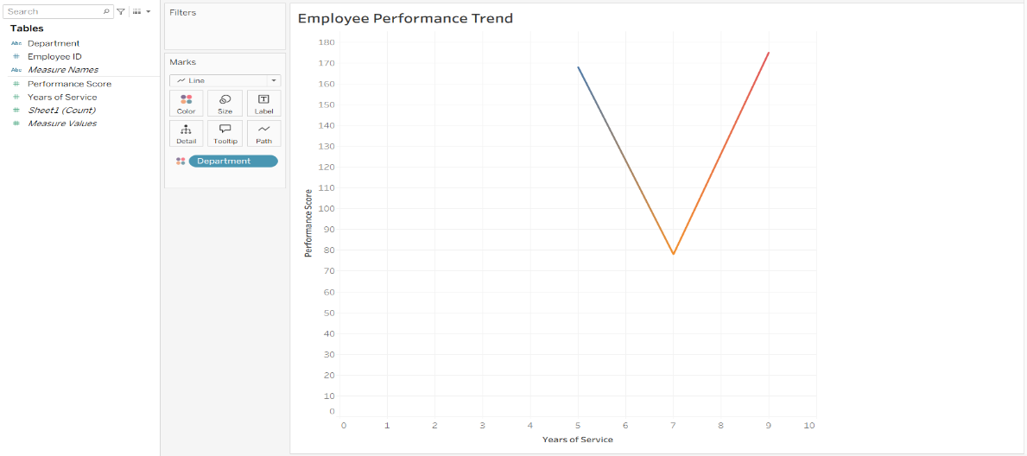

Task 2: Department-wise Employee Distribution
Procedure
- Open a new worksheet.
- Drag Department to Columns.
- Drag Number of Records to Rows.
- Select Bar Chart.
- Add labels.
- Edit title as Employees by Department.
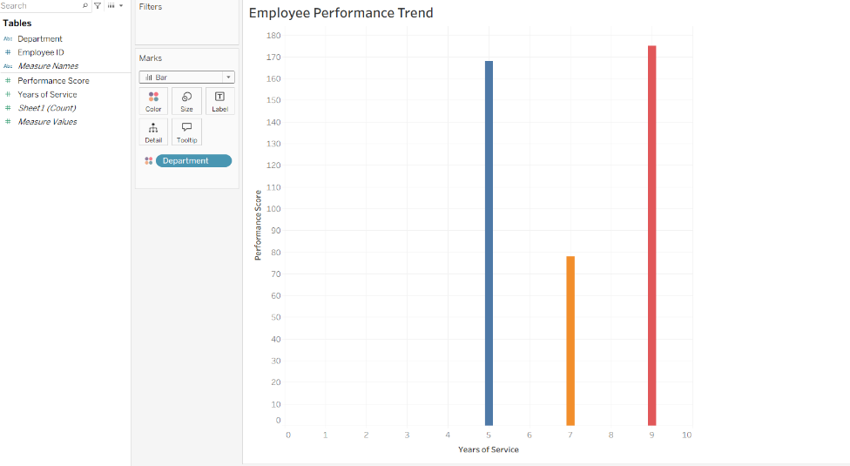

Task 3: Scatter Plot (Years of Service vs Performance)
Procedure
- Open a new worksheet.
- Drag Years of Service to Columns.
- Drag Performance Score to Rows.
- Select Scatter Plot.
- Drag Department to Color.
- Drag Employee ID to Label.
- Add chart title.
Insight
- If points rise from left to right, employees with more experience generally perform better.
- Randomly scattered points indicate a weak correlation.

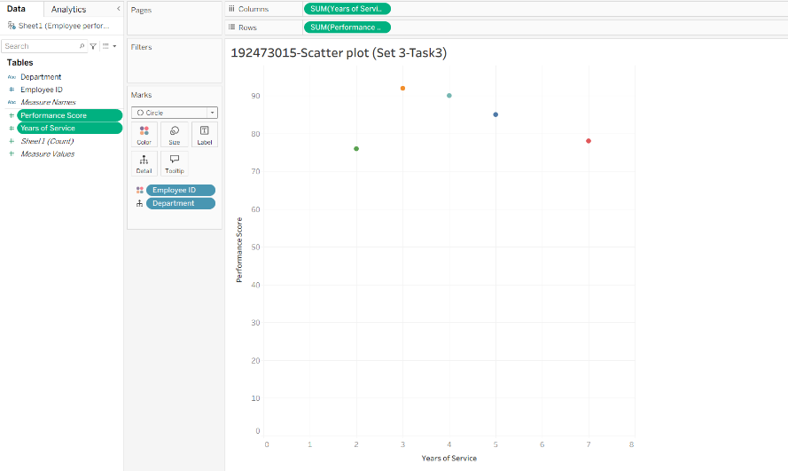

Task 4: Dashboard
Procedure
- Click New Dashboard.
- Add the Line Chart.
- Add the Department Bar Chart.
- Enable Use as Filter.
- Add dashboard title Employee Performance Dashboard.
- Save the workbook.

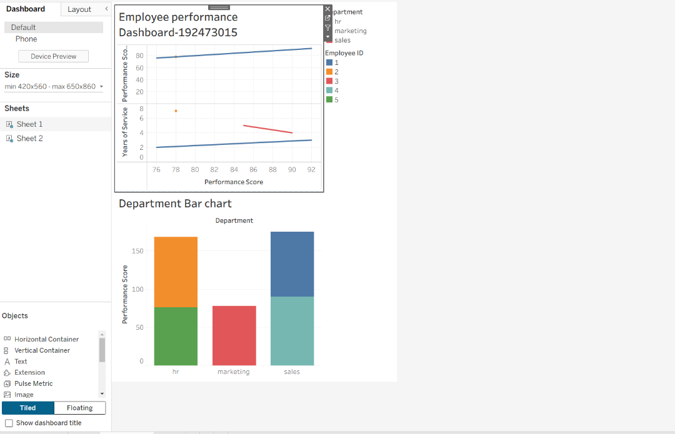

SET 4: Product Inventory Management
Task 1: Bar Chart (Inventory Quantity)
Procedure
- Load the Product Inventory dataset.
- Open a worksheet.
- Drag Product Name to Columns.
- Drag Quantity Available to Rows.
- Choose Bar Chart.
- Add labels.
- Title the chart Product Inventory Quantity.

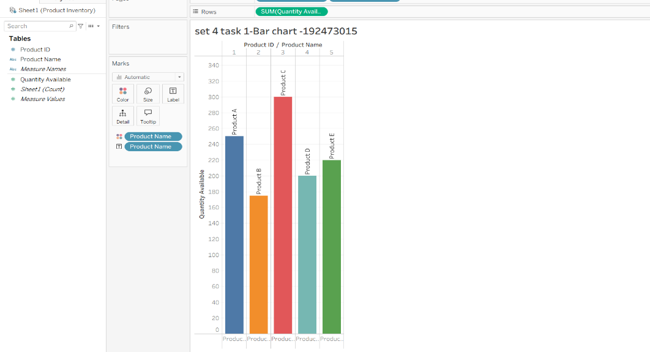

Task 2: Stacked Bar Chart (Product Categories)
Procedure
- Ensure the dataset contains a Product Category field.
- Drag Product Category to Columns.
- Drag Quantity Available to Rows.
- Drag Product Name to Color.
- Tableau creates a stacked bar chart.
- Add chart title Inventory by Product Category.

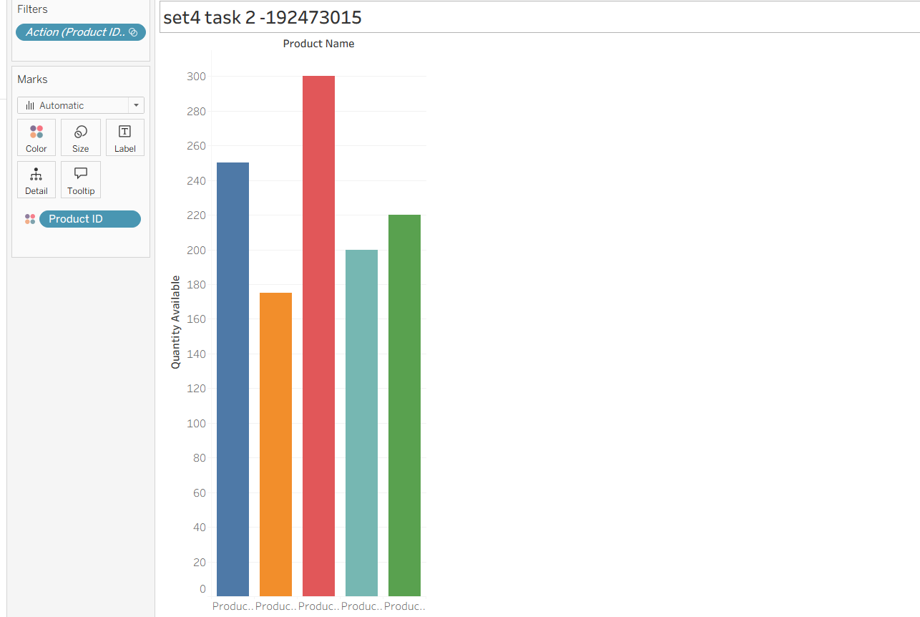

Task 3: Scatter Plot (Price vs Quantity)

Procedure
- Ensure the dataset contains a Product Price field.
- Open a new worksheet.
- Drag Product Price to Columns.
- Drag Quantity Available to Rows.
- Select Scatter Plot.
- Drag Product Name to Label.
- Edit the chart title.
Insight
- A downward trend suggests that higher-priced products tend to have lower inventory.
- An upward trend indicates higher-priced products also have higher stock levels.

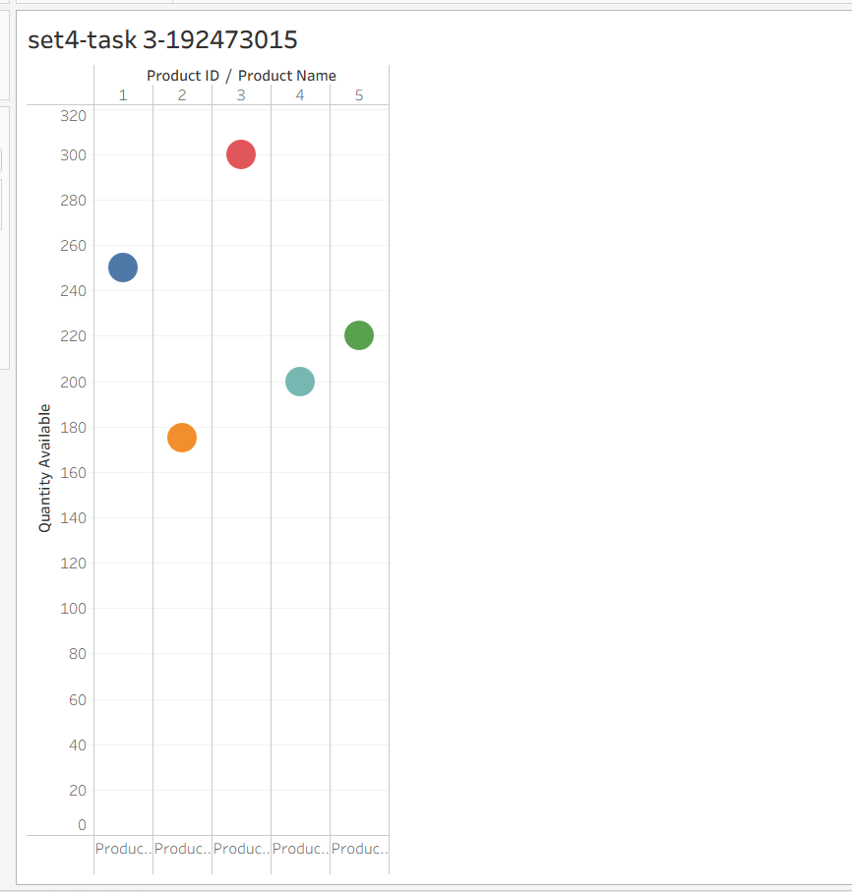

Task 4: Dashboard
Procedure
- Click New Dashboard.
- Add the Bar Chart.
- Add the Stacked Bar Chart.
- Enable Use as Filter for interactivity.
- Add dashboard title Product Inventory Dashboard.
- Save the workbook.
